To: | Scrutiny Committee
Date: | 05 February 2019
Report of: | Head of Regulatory Services & Community Safety
Title of Report: | Street Art

Summary and recommendations
Purpose of report: |  | The Scrutiny Committee requested a report to update them on the use of Street Art to reduce unwanted tagging in Oxford City
Key decision: |  | No
Executive Board Member: |  | Councillor Tom Hayes, Portfolio Holder for Community Safety
Corporate Priority: |  | None
Policy Framework: |  | None
Recommendations:That the Scrutiny Committee resolves to:
1. | Note and comment on the report; and
2. | Include any additional recommendations.

Introduction and background
- Graffiti is defined by the Oxford English Dictionary as writing or drawings scribbled, scratched, or sprayed illicitly on a wall or other surface in a public place. Tagging is defined by the Urban Dictionary as a way of signing your name anonymously. Street Art is defined by the Urban Dictionary as any art developed in public spaces. The term Street Art is often used to distinguish modern public-space artwork from traditional graffiti and the overtones of gang territoriality and vandalism associated with it.
In 2015 the Anti-Social Behaviour Investigation Team (ASBIT) organised an Appreciative Inquiry, following complaints of graffiti, to ask stakeholders their views on how to tackle it. Over 60 people attended; including residents, Councillors and partner agencies. It was agreed the Council would provide free wall space for local artists to draw on. A disused building on South Park was identified as a free wall space and local street artists were invited to paint on it. This continues to be a well-used Free Wall space and ASBIT have not received any further complaints of graffiti in the area.
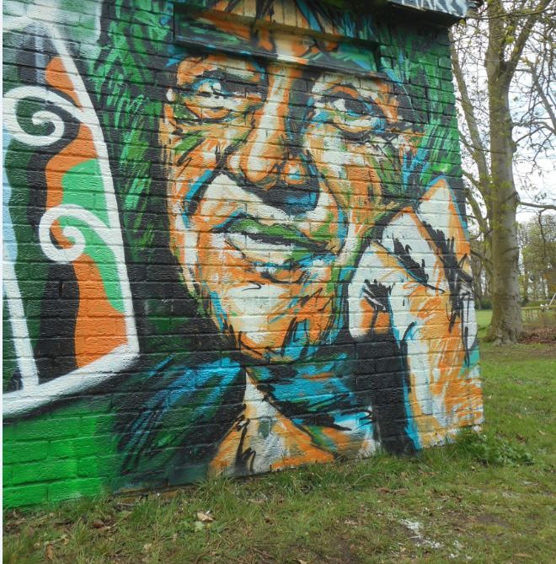
- Street Art Projects
In 2017 the Murco garage in Cowley closed down and brown hoarding was placed around the site. The hoarding attracted unwanted graffiti and tagging. ASBIT asked the Graffiti Removal Supervisor to remove it. However this did not stop people from painting graffiti on it. ASBIT made the decision to consult with Councillors, partner agencies, and local street artists about using the Murco site as a free wall area. In principal it was agreed. ASBIT organised further consultations to determine the best way forward. The final consultation took place in the Cowley Centre. 150 people participated and were asked for their opinion on whether they would like to see Street Art on the hoarding; if yes what genre of art and what would they like to see. 135 people agreed with the Murco site being used for street art, 14 people disagreed and one person didn’t mind. The main themes identified by the public were:
1. Vibrant and colourful
2. Street Art
3. Reflecting Cowley
4. Traditional
5. Childrens involvement
6. Embracing community cohesion
Local DIY stores donated paint towards the project. Artists began painting on 2 June 2018 and continued for 3 months. It has been used to publicise the Restore and Elder Stubbs festival in August 2018 with members of both groups involved in the painting and design. Oxford City Council’s Youth Ambition Team worked with young people to create more art at the site in the summer holidays 2018. This is well used free wall space that is monitored weekly. The artwork changes from week to week and ASBIT have not received any reports of any offensive tagging at the site since the artwork started.
Before: After:
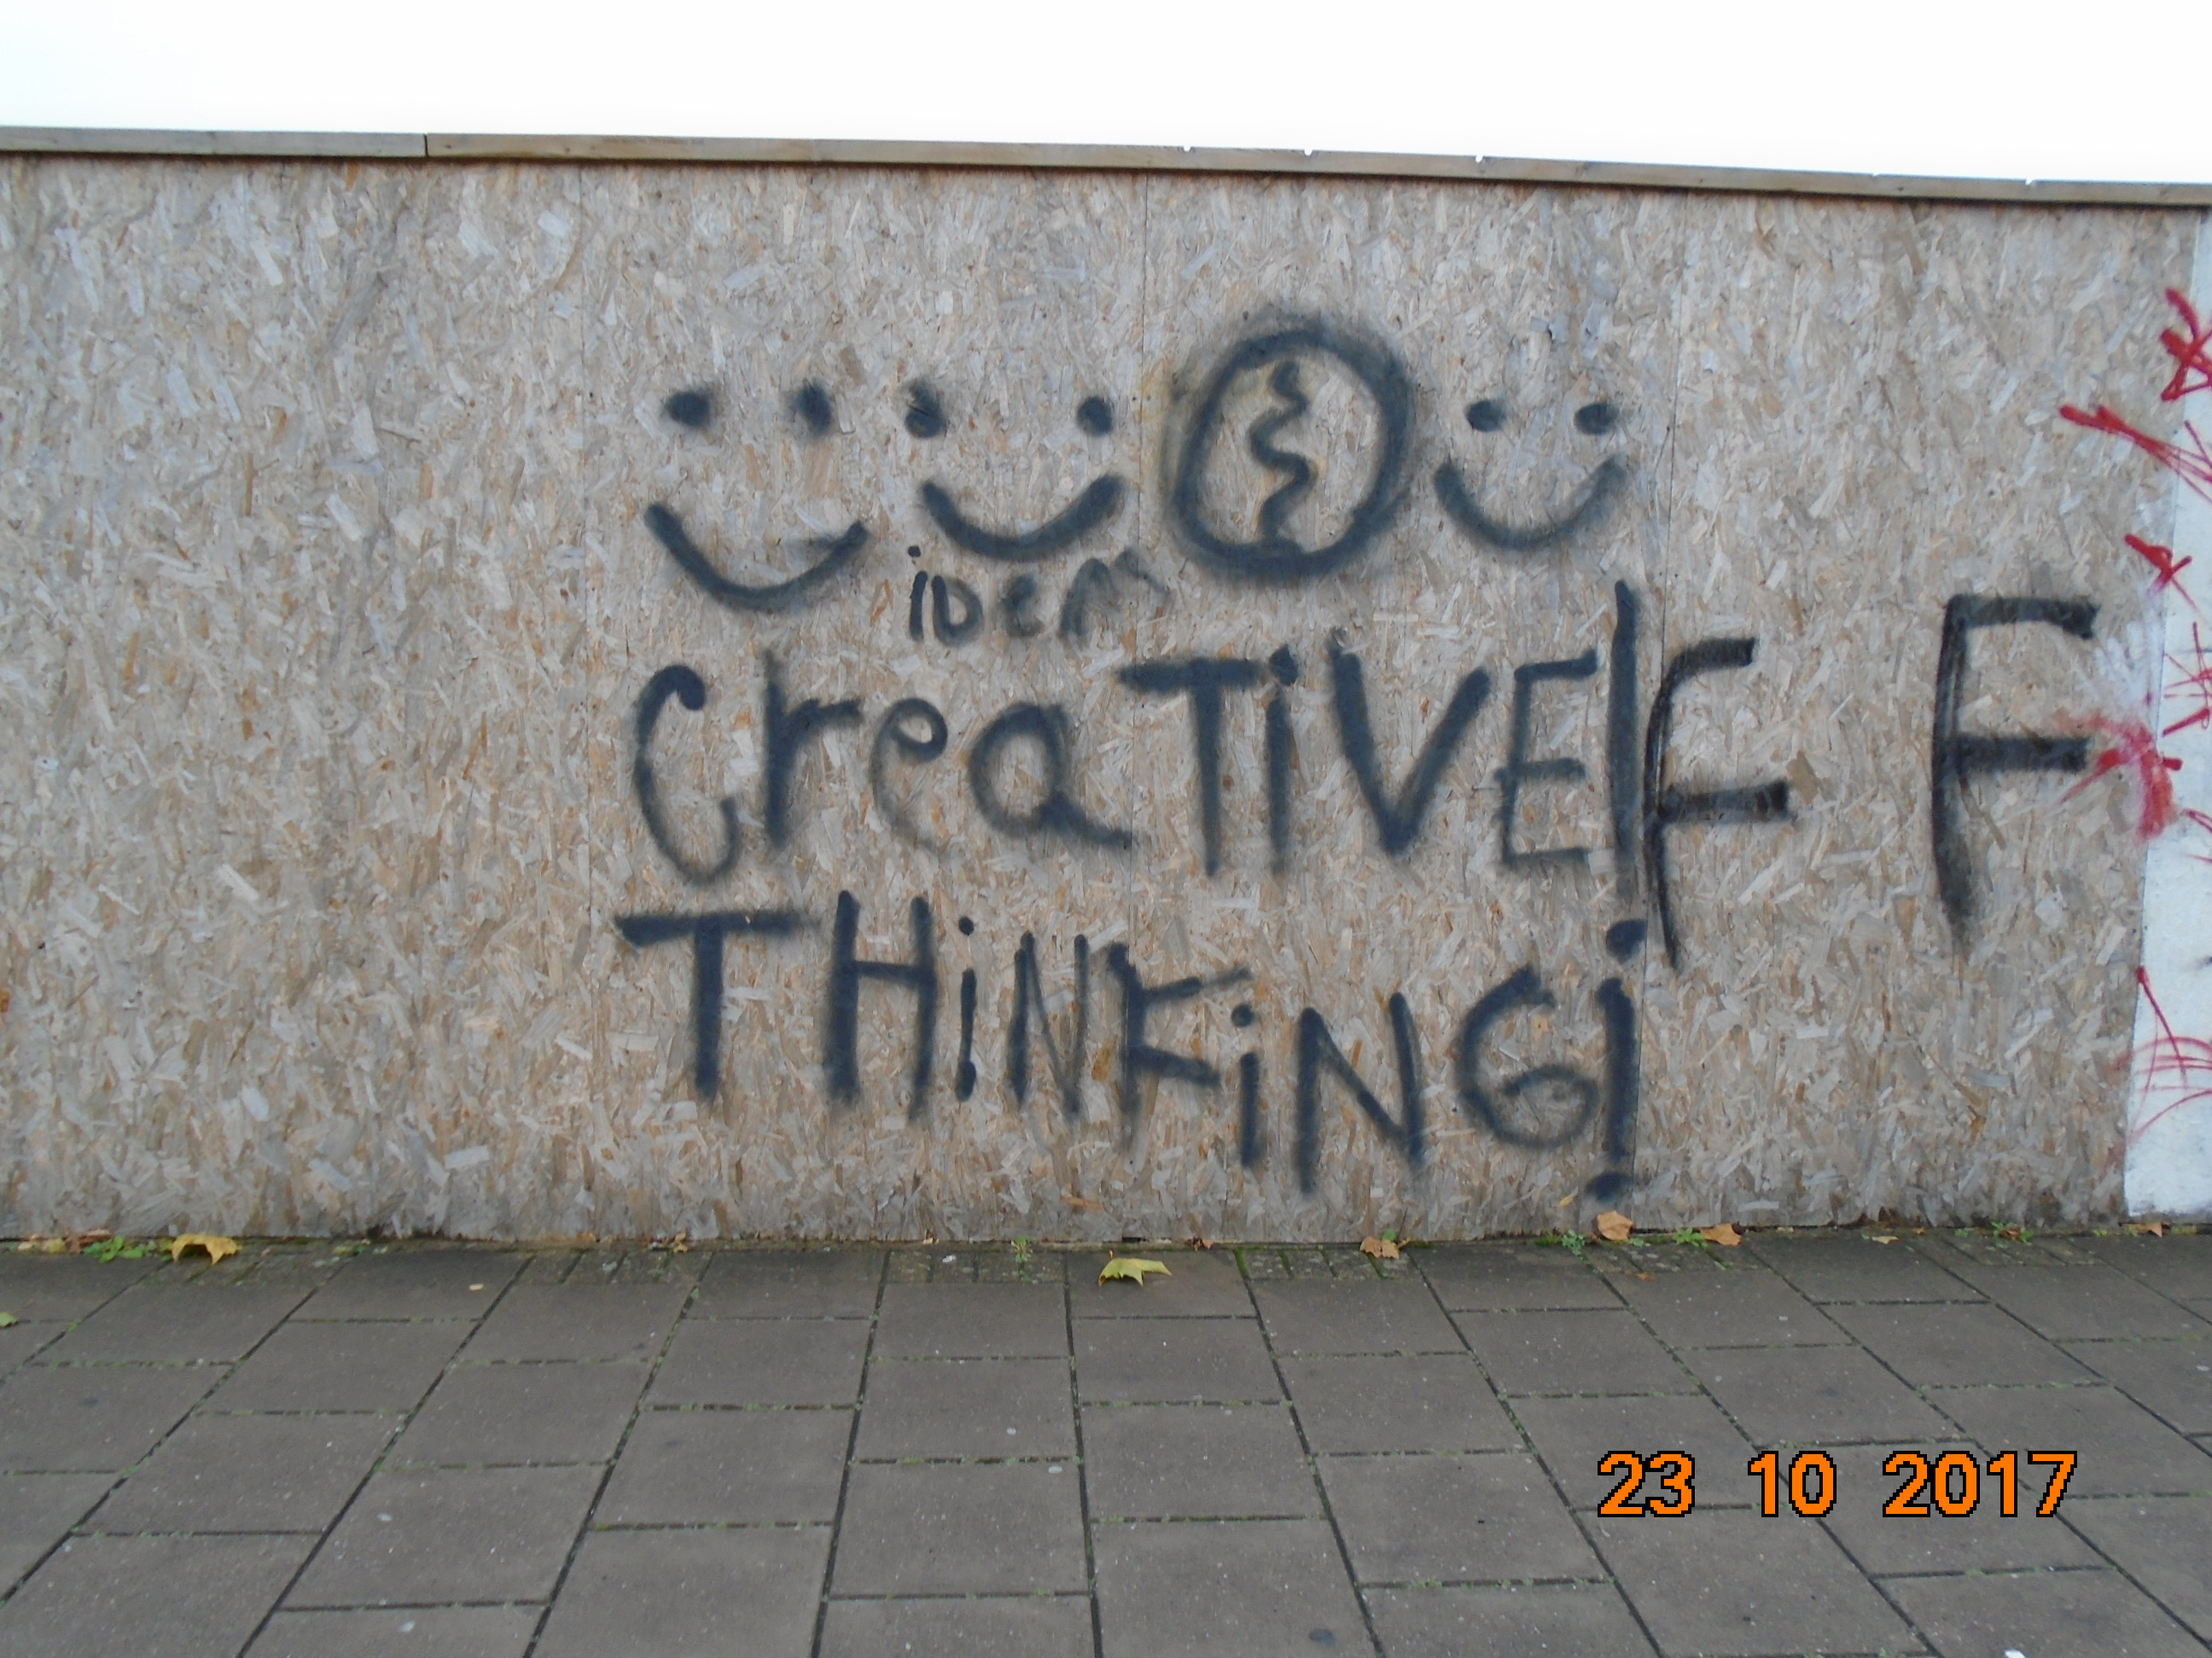 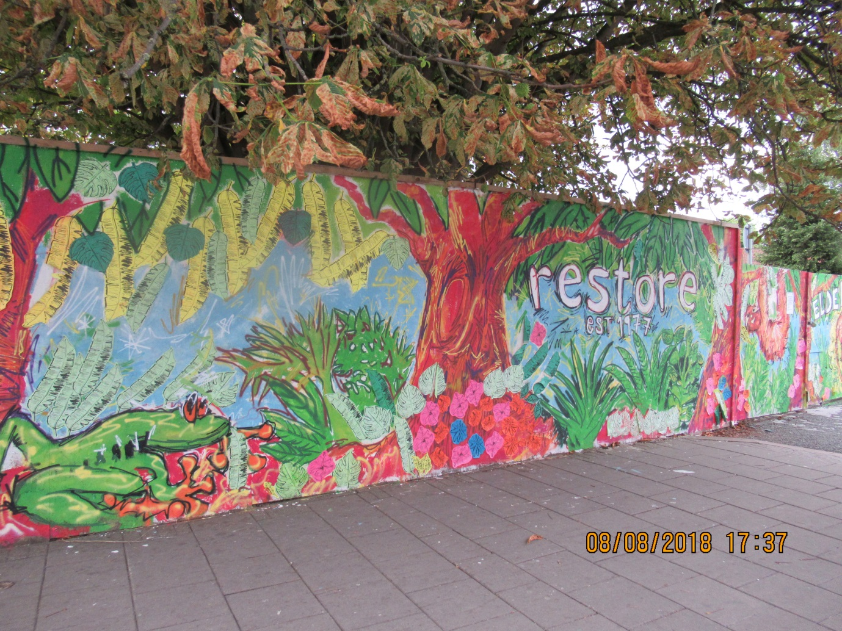
- At the end of October 2018 ASBIT was made aware of unwanted graffiti on the wall surrounding the Convent of Incarnation in Meadow Lane. Alison Cassidy and Liz Jones met the Sisters at the Convent on 9 November to discuss a potential mural on the wall that would cover the unwanted graffiti and also deter any further tagging. This would not include a free wall site as it is a commissioned piece of street art. The Sisters were very open to the idea and asked to be included in the thoughts for the design as a number of their nuns were keen artists. Alison updated stakeholders, including Councillors, on the proposed project. ASBIT has been coordinating the project and identified a lead street artist, Andrew Manson. Mr Manson has sketched out ideas and identified other local artists who would be happy to paint at the extensive Convent site. Funding is currently being sought to pay for the mural to match the funding the Sisters have offered as a contribution. Alison and Mr Manson are due to meet with the Sisters on 28 January to discuss the design and the next steps.
- Towards the end of 2018 Alison was linked into a project run by Tim Cann. St Nicholas Primary School is painting a mural on the Marston underpass. Alison was made aware of other underpasses and bridges where there was unwanted graffiti and tagging. She arranged a meeting with Ewan Siret, Senior Bridge Technician from Oxfordshire County Council. He has given permission for Alison to organise street art projects on three sites;
1. Donnington Bridge underpass opposite the existing mural.
2. The 3 subways at Redbridge
3. The abutment wall in Barnes Road
This project is in the very early stages and has not yet gone out to consultation.

Report author | Alison Cassidy
Job title | Case Manager
Service area or department | Regulatory Services & Community Safety
Telephone | 01865 252745
e-mail | acassidy@oxford.gov.uk

Background Papers: None

